Connect-4
Implement the board as an array of vectors on the backend and a grid of labels/boxes on the front end. Have the button inputs change only the array and have the grid be based soley on the array.
Button need only be placed on the top, as you can only select the column that you wish to move in.
Need a program to scan the array for winning board states.
Can make such a program from one that checks a single row/column at a time and iterate over the array.
Then a custom program specifically for diagonals (challenge)
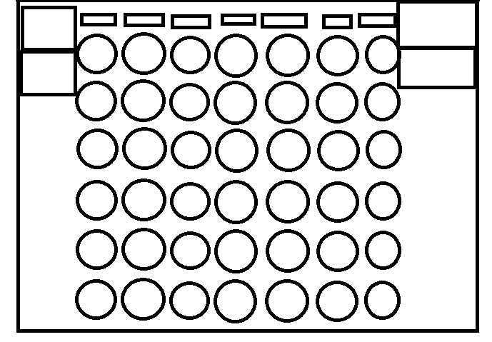

Memory Game
Implement the board as an array of vectors. Each index will contain a symbol depending on whether it is flipped or not and if flipped what picture is shown.
This can be reflected on the screen with a grid of buttons which contain images of either the back or front of a virtual card.
When 2 cards are clicked, they flip and the program can compare them in the array.
